**Ex. No: 15 TRAFFIC SIGNAL – ARDUINO**

**Aim**

To design and simulate a basic traffic signal system using Arduino in Tinkercad.

**Components Required**

|  |  |  |  |  |
| --- | --- | --- | --- | --- |
| **Sl.No** | **User Defined Name** | **Quantity** | **Component List** | |
|  | UArduino Uno | 1 | Arduino Uno R3 | |
|  | DLED_1 | 1 | Green LED | |
|  | DLED_2 | 1 | Orange LED | |
|  | DLED_3 | 1 | Red LED |  |
|  | RRES_1, RRES_2, RRES_3 | 3 | 220 Ω Resistor | |

**Procedure:**

1. Open Tinkercad.

2. Click on Create New Circuit.

3. Select the Breadboard.

4. Select the required LED.

5. Select the Arduino.

6. Select Resistors. Set the resistance to 220 ohms.

7. Provide the appropriate connections.

8. Write the code.

9. Start Simulation.

10. LED glows

**Circuit Design**

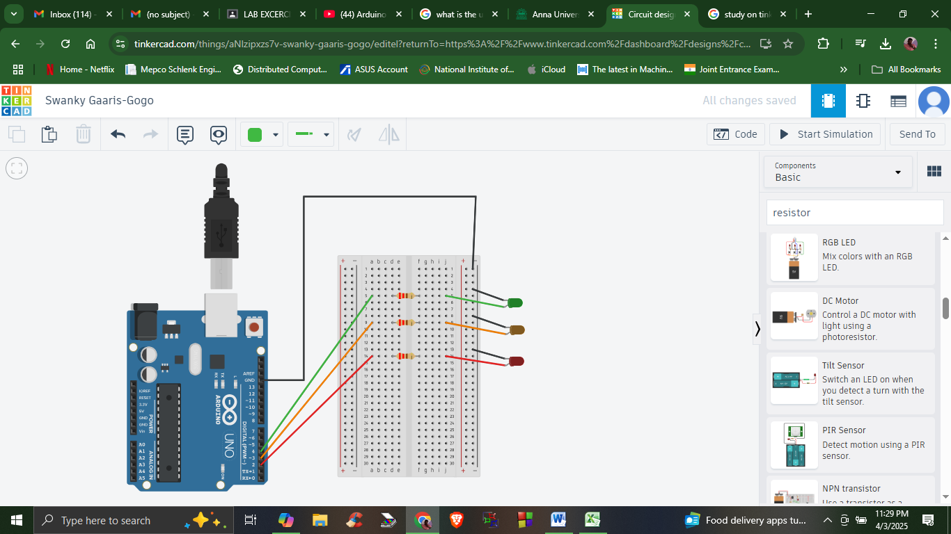

**Source Code**

void setup()

{

pinMode(4, OUTPUT);

pinMode(3, OUTPUT);

pinMode(2, OUTPUT);

}

void loop()

{

digitalWrite(4, HIGH);

delay(3000); // Wait for 1000 millisecond(s)

digitalWrite(4, LOW);

digitalWrite(3, HIGH);

delay(3000); // Wait for 1000 millisecond(s)

digitalWrite(3, LOW);

digitalWrite(2, HIGH);

delay(3000); // Wait for 1000 millisecond(s)

digitalWrite(2, LOW);

}

**Output - Green LED glowing**

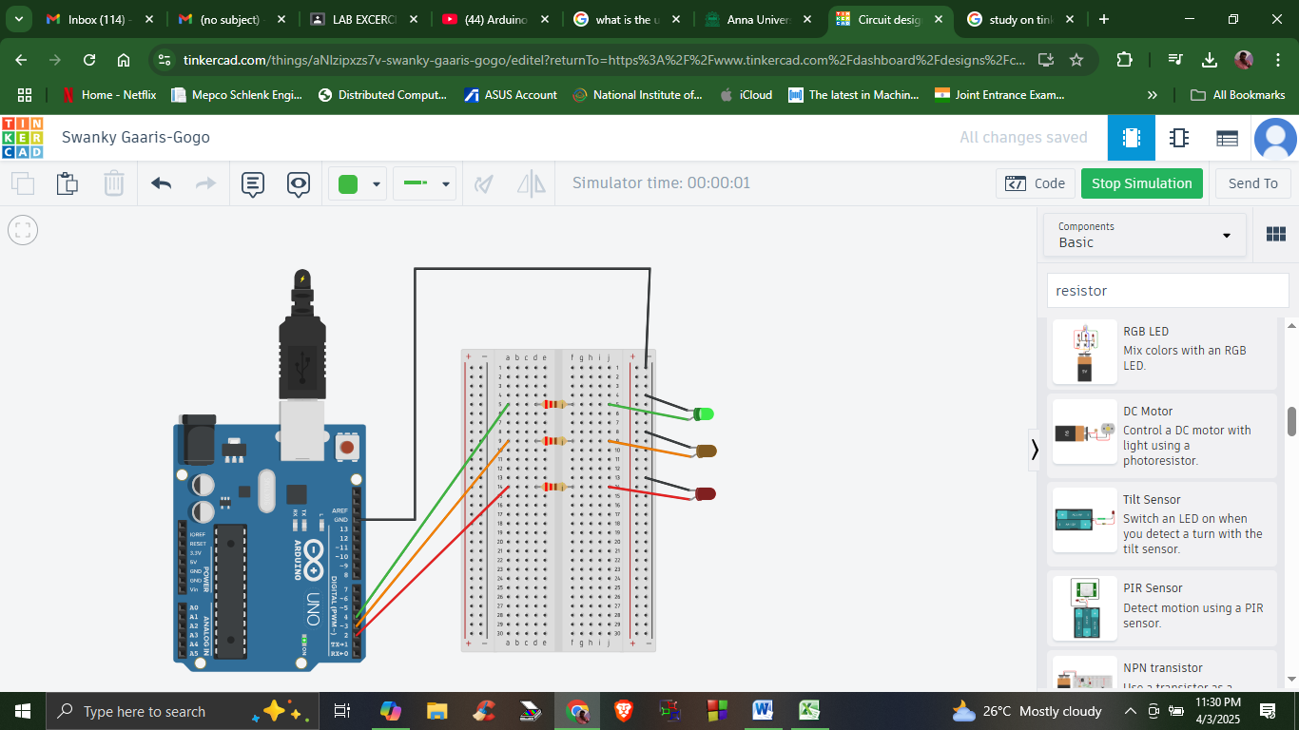

**Output - Orange LED glowing**

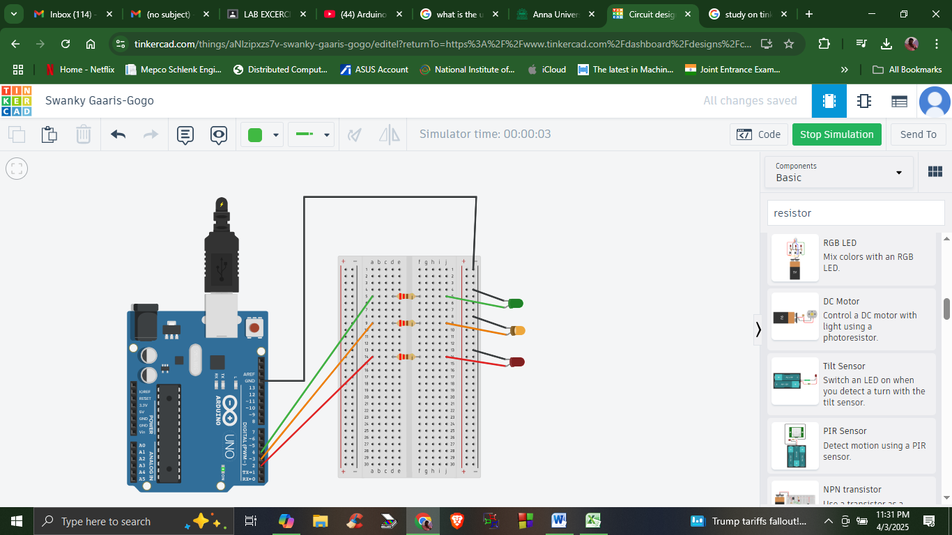

**Output - Red LED glowing**

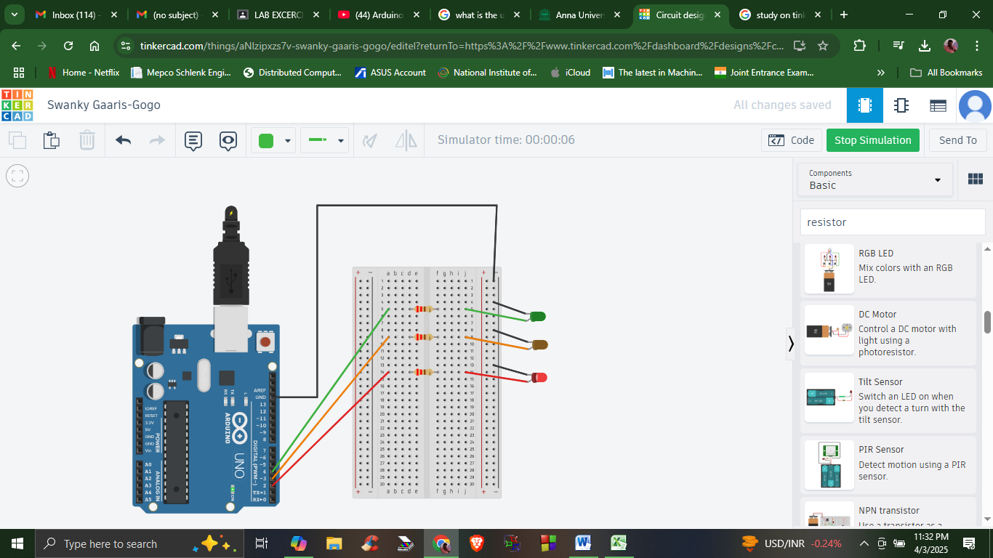

**Result**

Hence, the program to simulate a traffic signal using Arduino in Tinkercad has been successfully developed, and its functionality has been verified through simulation.